CREDIT RISK MODELING REPORT
Basel II/III Expected Loss Framework
Lending Club Loan Portfolio — 2007–2018
Project: Financial Risk Analysis
Scope: Stages 5–9 — Data Preparation, PD, LGD, EAD, Portfolio EL
Date: July 2026
Author: Diego Gomez
CONFIDENTIAL

Table of Contents
Executive Summary
1. Framework Overview
2. Data Preparation (Stage 5)
2.1 Dataset
2.2 Out-of-Time Split
2.3 Leakage Prevention
2.4 Redundant Feature Removal
3. Probability of Default Model (Stage 6)
3.1 Modelling Approach
3.2 Results
4. Loss Given Default Model (Stage 7)
4.1 Target Definition
4.2 Cure Rate Analysis
4.3 Severity Model Results
5. Exposure at Default Model (Stage 8)
5.1 Amortisation Framework
5.2 Descriptive Statistics
5.3 CCF Model Results
6. Portfolio Expected Loss (Stage 9)
6.1 Portfolio Summary
6.2 EL by Grade
6.3 EL by Loan Purpose
6.4 Model Calibration
7. Key Findings & Recommendations
7.1 Summary of Findings
7.2 Recommendations

Executive Summary
This report presents the results of a Basel II/III Expected Loss (EL) credit risk model built on the Lending Club peer-to-peer lending dataset, covering 1.37 million loans ($19.84 billion in originations) originated between 2007 and 2018. The framework decomposes credit risk into three independently modelled components:
- Probability of Default (PD): likelihood a borrower fails to repay
- Loss Given Default (LGD): fraction of exposure lost if default occurs
- Exposure at Default (EAD): outstanding principal at the moment of default

An out-of-time validation methodology was applied throughout: models were trained on 2007–2016 originations and tested on the 2017–2018 cohort. This prevents data leakage and mirrors real-world model deployment conditions.

1.37M  Total Loans  $19.84B volume | 0.6831  PD Model AUC  Logistic Regression champion | $2,806M  Total Portfolio EL  13.10% mean EL rate

0.2163  LGD Test MAE  −19% vs naive baseline | 0.1908  EAD Test MAE  −7% vs naive baseline | 1.54×  Calibration Ratio  Train set predicted/actual

The PD model (Logistic Regression) correctly ranks borrowers by risk with an out-of-time AUC of 0.6831 and KS statistic of 0.2667. EL rates increase monotonically from grade A (5.33%) to grade G (34.52%), confirming that the model’s risk ordering aligns with Lending Club’s own rating structure. The portfolio exhibits high concentration in debt consolidation loans, which account for 64.5% of total expected losses despite carrying only a middle-of-the-range EL rate — credit card loans add a further 18.8%, so the two largest refinancing purposes together account for 83.3% of total portfolio EL.
A systematic over-prediction of 1.54× on the training set is identified and attributed to the balanced-class-weight regularisation applied during PD model training. Platt scaling of predicted probabilities is recommended as the primary improvement for production deployment.

1. Framework Overview
The Basel II/III credit risk framework quantifies the expected loss on a loan portfolio as:
EL ($) = PD × LGD × EAD
Each component captures a distinct dimension of credit risk. Together they produce a dollar-denominated provision that a bank must hold against expected future losses. This report covers Stages 5 through 9 of the project:

Stage | Notebook | Description | Output
5 | 05_data_preparation | Feature selection, leakage removal, multicollinearity check, out-of-time split | 6 parquet files
6 | 06_PD_model | Probability of Default (binary classification) | pd_scores.parquet
7 | 07_LGD_model | Loss Given Default (severity regression) | lgd_scores.parquet
8 | 08_EAD_model | Exposure at Default (CCF amortisation model) | ead_scores.parquet
9 | 09_Expected_Loss_portfolio | EL = PD × LGD × EAD, portfolio aggregation | Portfolio report

2. Data Preparation (Stage 5)

2.1 Dataset
The Lending Club dataset covers all loans originated between 2007 and 2018, providing a complete picture of the platform’s credit history from inception through maturity. After cleaning (Stages 1–4), the analytical dataset contains 1,371,165 loans across 20 features. After leakage removal and multicollinearity checks (below), the modelling feature set used for PD training is reduced to 15 features.

Attribute | Value
Total loans | 1,371,165
Total loan volume | $19.84 billion
Date range | 2007–2018
Cleaned dataset columns | 20
PD modelling feature count | 15
Train set (2007–2016) | 1,127,206 loans (82.2%)
Test set (2017–2018) | 243,959 loans (17.8%)
Train default rate | 20.23%
Test default rate | 27.20% (censored — see below)

2.2 Out-of-Time Split
Models are trained on 2007–2016 originations and evaluated on the 2017–2018 cohort. This out-of-time (OOT) split is the industry standard for credit model validation: it prevents the model from being evaluated on loans whose outcomes it has implicitly seen during training, mimicking real deployment conditions where the model scores new borrowers it has never encountered.
The test set shows a higher observed default rate (27.20%) than the training set (20.23%). This is a known artefact of loan maturity censoring: the 2017–2018 loans had not fully run to maturity when the dataset was compiled. A loan can be flagged as default within months, while a full repayment generally requires the loan to reach the end of its term — so fast-resolving defaults are over-represented relative to still-performing loans in the test cohort, inflating the observed default rate above what the fully-matured vintage will likely show. This finding is documented and carried through all subsequent stages.

2.3 Leakage Prevention
One variable was identified and excluded from all model feature sets:
- total_pymnt: total payments received — collected after the loan outcome is known

This variable is only observable after default status is known, making it post-outcome leakage. Including it would produce artificially high model performance that would not replicate in production.
A related pre-origination variable, ever_delinq (a flag derived from months since the borrower’s last delinquency, known at underwriting), was reviewed and confirmed to be a legitimate feature — it is known before loan origination and is correctly retained in the model.

2.4 Redundant Feature Removal
A multicollinearity check on the training set identified two feature pairs that are near-duplicates of each other:
- grade and int_rate (r = 0.955) — the platform prices loans almost entirely by grade, so interest rate carries little signal beyond it
- loan_amnt and installment (r = 0.954) — installment is arithmetically derived from loan amount, rate, and term

Keeping both members of a pair adds no predictive power and destabilises a linear model’s coefficients. int_rate and installment are dropped; grade (converted to a numeric ordinal scale, A→G mapped to 1–7) and loan_amnt are kept as the more interpretable, non-redundant signal. A softer correlation between total_acc and open_acc (r = 0.699) was reviewed and both features were retained, since each carries meaningful independent variance (r² ≈ 0.49). This reduces the modelling feature set from 17 to 15 columns.

3. Probability of Default Model (Stage 6)

3.1 Modelling Approach
The PD model is a binary classification problem: predict whether a loan will default (1) or be fully repaid (0), using the 15-feature set from Stage 5. Two models were trained and compared using out-of-time metrics:
- Champion: Logistic Regression with StandardScaler and class_weight=’balanced’
- Challenger: LightGBM with scale_pos_weight and early stopping (50 rounds)

Evaluation used two complementary metrics: AUC-ROC (overall discrimination) and the KS statistic (maximum separation between default and non-default score distributions), which is standard in retail credit risk.

3.2 Results
Model | Train AUC | Test AUC | Test KS | AUC Gap | Decision
Logistic Regression | 0.7060 | 0.6831 | 0.2667 | 0.0229 | CHAMPION
LightGBM | 0.7062 | 0.6800 | 0.2646 | 0.0262 | Challenger

Logistic Regression was selected as the champion model. Although both models achieve similar training performance, Logistic Regression generalises better out-of-time: it has a smaller train-test AUC gap (0.0229 vs 0.0262) and higher test KS. LightGBM shows signs of mild overfitting to the training vintage.
This result is counterintuitive but common in credit risk: the regulatory environment and relatively limited feature set (15 features, all available at origination) leaves little signal that a complex tree-based model can exploit beyond what a linear model captures. Feature coefficients also confirm this: grade’s coefficient (0.410) is the single largest in the model — it absorbed most of int_rate’s signal once that column was dropped for multicollinearity in Stage 5. Interpretability is a secondary benefit of the logistic regression champion.
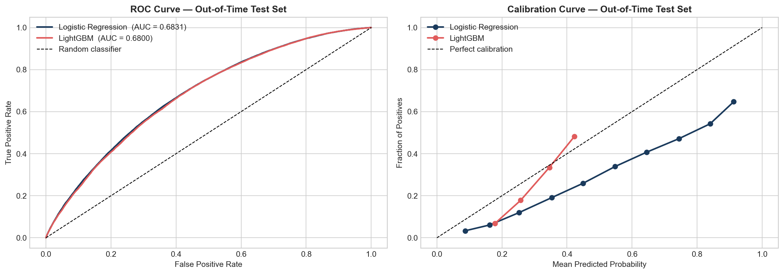
Figure 1 — ROC and calibration curves, out-of-time test set (Logistic Regression vs LightGBM)

4. Loss Given Default Model (Stage 7)

4.1 Target Definition
LGD is defined as the fraction of the outstanding loan amount not recovered after default:
LGD = 1 − (total_pymnt / loan_amnt), clipped to [0, 1]
The model is estimated on defaulted loans only (294,415 loans in the combined dataset). A cure rate analysis was conducted first to assess whether a two-stage approach (cure rate classifier + severity regressor) was feasible.

4.2 Cure Rate Analysis
In industry practice, defaulted loans are classified as “cured” (near-full recovery, LGD < 5%) or “non-cured” before modelling severity. However, the out-of-time test exposed a critical data limitation:

Split | Mean LGD | Cure Rate | Interpretation
Train (2007–2016) | 0.4117 | 12.59% | Loans matured — recoveries observed
Test (2017–2018) | 0.6584 | 0.37% | Censored — no time to recover

The 2017–2018 defaulted loans had almost no time to generate recovery payments before the dataset was compiled. Cure rate classifiers trained on the 12.59% training base rate predict near-random AUCs (Logistic Regression: 0.569, LightGBM: 0.506) on the test set. The two-stage model cannot generalise across this censoring boundary.
Decision: the cure rate stage is retained for documentation purposes but excluded from the production estimate. The final LGD model is a severity-only regressor trained exclusively on non-cured training loans.

4.3 Severity Model Results
Approach | Test MAE | Test RMSE | Test R² | vs Baseline
Mean baseline | 0.2678 | 0.3061 | −1.8517 | —
Single-stage LightGBM | 0.2554 | 0.2938 | −1.6277 | −5%
Severity model (ours) | 0.2163 | 0.2533 | −0.9526 | −19%

The severity model (LightGBM trained on non-cured loans only) reduces MAE by 19% versus the mean baseline and 15% versus the single-stage approach. All R² values are negative because the test set’s mean LGD (0.6584) differs substantially from the training mean (0.4117) due to censoring. MAE is the appropriate evaluation metric in this setting: it measures absolute prediction error regardless of distributional shift.

5. Exposure at Default Model (Stage 8)

5.1 Amortisation Framework
For installment loans, EAD is the remaining principal balance at the time of default. This is computed analytically from the loan’s amortisation schedule:
B(k) = loan_amnt × (1 + r)ᵏ − installment × [(1 + r)ᵏ − 1] / r
where r = int_rate / 12 is the monthly interest rate and k is the number of payments made before default. The Credit Conversion Factor (CCF = EAD / loan_amnt) is modelled from origination features to generate loan-level EAD estimates.

5.2 Descriptive Statistics
Metric | Train (2007–2016) | Test (2017–2018)
Mean EAD ($) | $9,879 | $13,312
Mean CCF | 0.6164 | 0.8005
Median payments made (k) | 19 | 10

The same censoring pattern observed in LGD appears in EAD. Test defaults occurred after a median of only 10 payments (vs 19 for training defaults), leaving a higher fraction of principal outstanding (CCF 0.80 vs 0.62). The two effects are internally consistent: fast defaults produce both higher LGD (less total recovery) and higher CCF (less principal repaid) simultaneously.

5.3 CCF Model Results
Approach | Test MAE | Test RMSE | Test R² | vs Baseline
Mean baseline | 0.2048 | 0.2298 | −1.7908 | —
Grade × Term segments | 0.2045 | 0.2311 | −1.8220 | 0%
LightGBM (ours) | 0.1908 | 0.2168 | −1.4832 | −7%

The grade × term segment baseline does not improve upon the simple mean, confirming that CCF is driven by time-to-default rather than loan quality grade. LightGBM reduces absolute error by 7% over the mean baseline. Early stopping triggered at iteration 28, reflecting limited learnable signal at origination.

6. Portfolio Expected Loss (Stage 9)

6.1 Portfolio Summary
$19.84B  Loan Volume  1,371,165 loans | $2,806M  Total Predicted EL  13.10% mean EL rate | 1.54×  Calibration Ratio  Predicted / Actual (train)

Split | Loans | Predicted EL | Actual Losses | Ratio
Train (2007–2016) | 1,127,206 | $2,268M | $1,478M | 1.535
Test (2017–2018) * | 243,959 | $539M | $725M * | N/A
Total | 1,371,165 | $2,806M | — | —

* Test actual losses are inflated by censoring: 2017–2018 defaults had not yet generated recovery payments at the dataset snapshot date.

6.2 EL by Grade
EL rates increase monotonically from grade A to G, confirming the model’s risk ordering aligns with Lending Club’s own rating structure.

Grade | Loans | Volume ($M) | Total EL ($M) | % of EL | Mean PD | Mean EL Rate
A | 236,758 | $3,293 | $176 | 6.3% | 23.6% | 5.33%
B | 398,528 | $5,291 | $501 | 17.9% | 37.4% | 9.18%
C | 390,724 | $5,569 | $816 | 29.1% | 50.5% | 14.03%
D | 206,696 | $3,168 | $621 | 22.1% | 61.5% | 18.78%
E | 96,224 | $1,697 | $431 | 15.4% | 72.3% | 24.61%
F | 32,828 | $628 | $192 | 6.9% | 80.4% | 29.99%
G | 9,407 | $194 | $68 | 2.4% | 85.8% | 34.52%

Grade G carries 6.5× the EL rate of grade A. Grade C accounts for the largest share of total portfolio EL ($816M, 29.1%) not because it is the riskiest segment but because it is the most heavily originated.
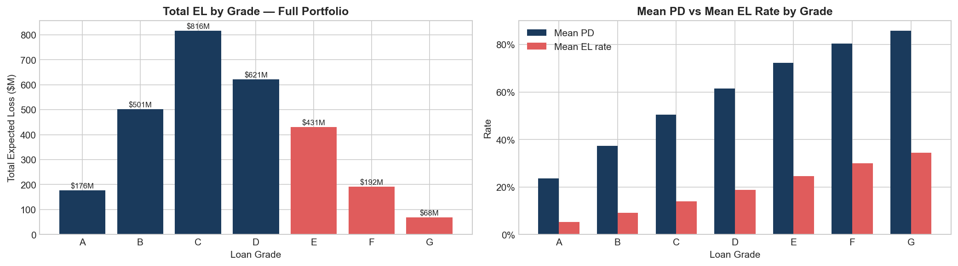
Figure 2 — Total Expected Loss and mean PD/EL rate by loan grade, full portfolio

6.3 EL by Loan Purpose
Loan purpose is a proxy for borrower intent and repayment behaviour. The 14 purpose categories captured at origination are decomposed below, ranked by total dollar contribution to portfolio EL:

Purpose | Loans | Mean EL Rate | Total EL ($M) | % of Portfolio EL
Debt consolidation | 795,338 | 13.87% | $1,811 | 64.5%
Credit card | 300,119 | 11.05% | $527 | 18.8%
Home improvement | 89,273 | 12.18% | $171 | 6.1%
Other | 79,791 | 13.83% | $121 | 4.3%
Major purchase | 30,102 | 12.18% | $50 | 1.8%
Small business | 15,826 | 16.69% | $44 | 1.6%
Medical | 15,899 | 13.65% | $22 | 0.8%
House | 7,483 | 15.54% | $19 | 0.7%
Car | 14,810 | 10.56% | $16 | 0.6%
Moving | 9,701 | 14.50% | $12 | 0.4%
Vacation | 9,252 | 11.99% | $7 | 0.3%
Wedding | 2,294 | 12.57% | $3 | 0.1%
Renewable energy | 951 | 14.87% | $2 | 0.1%
Educational | 326 | 10.54% | $0.2 | 0.0%

Small business loans carry the highest EL rate (16.69%) but represent only $44M in total EL — 1.2% of the portfolio by loan count. Debt consolidation loans have a middle-of-the-road EL rate (13.87%, close to the 13.10% portfolio average) but account for $1,811M — 64.5% of total portfolio EL — purely due to volume concentration (795,338 loans, 58.0% of all originations). Credit card is the second-largest concentration ($527M, 18.8% of EL) despite a below-average EL rate (11.05%). Together, debt consolidation and credit card — the two refinancing-oriented purposes — account for 83.3% of total portfolio EL. Any systemic deterioration in either segment would dominate portfolio losses.
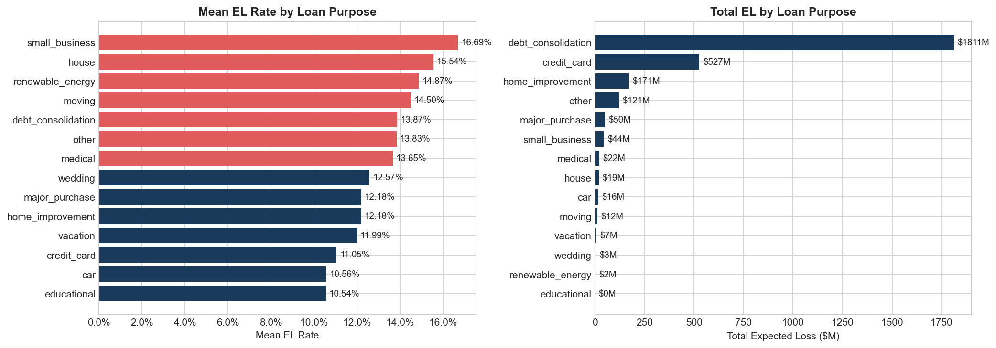
Figure 3 — Mean EL rate and total EL by loan purpose, full portfolio (14 categories)

6.4 Model Calibration
Calibration is assessed on the training set (2007–2016), where loan outcomes have fully resolved. The model over-predicts actual losses at every grade level:

Grade | Predicted EL ($M) | Actual Loss ($M) | Pred EL Rate | Actual Loss Rate | Ratio
A | $147 | $64 | 5.33% | 2.32% | 2.30
B | $411 | $242 | 9.35% | 5.50% | 1.70
C | $641 | $429 | 14.44% | 9.68% | 1.49
D | $497 | $348 | 19.38% | 13.54% | 1.43
E | $363 | $251 | 25.05% | 17.33% | 1.45
F | $161 | $112 | 30.03% | 20.87% | 1.44
G | $49 | $33 | 34.46% | 22.91% | 1.50
Total | $2,268 | $1,478 | — | — | 1.54

The calibration bias is most pronounced for grade A (ratio 2.30×) and stabilises for grades C–G (approximately 1.43–1.50×). The root cause is the use of class_weight=’balanced’ in the PD Logistic Regression: this technique improves AUC by up-weighting rare default events during training but inflates predicted probabilities above the true empirical default rate (mean predicted PD: 46.2% vs actual train default rate: 20.2%). The model correctly ranks borrowers by risk but overstates absolute probability magnitudes.
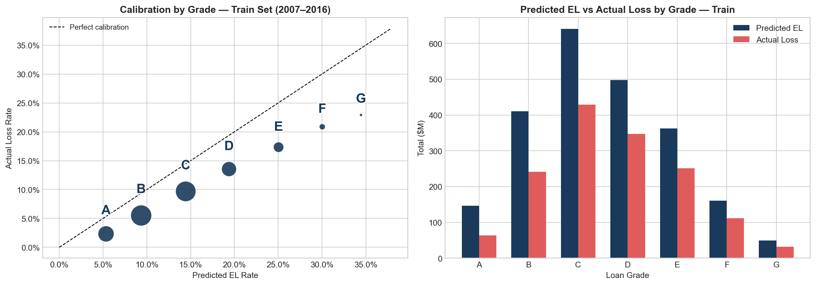
Figure 4 — Calibration by grade: predicted EL vs. actual realised loss, training set (2007–2016)

7. Key Findings & Recommendations

7.1 Summary of Findings
The Expected Loss framework successfully quantifies credit risk at the loan and portfolio level across 1.37 million Lending Club loans. Four principal findings emerge:

Finding 1 — Grade monotonicity confirmed
EL rates increase strictly and substantially from grade A (5.33%) to grade G (34.52%). Grade G carries 6.5× the expected loss rate of grade A. This validates the model’s discriminative power and confirms alignment with Lending Club’s proprietary rating system.

Finding 2 — Volume concentration in debt consolidation and credit card
Debt consolidation loans account for 64.5% of total portfolio EL ($1,811M of $2,806M). This concentration arises from volume, not elevated risk per se: debt consolidation carries a middle-range EL rate of 13.87%. Credit card loans add a further 18.8% of total EL despite a below-average rate (11.05%). Together the two refinancing purposes represent 83.3% of total portfolio EL. Any macro-level deterioration in consumer debt refinancing behaviour would disproportionately affect portfolio performance.

Finding 3 — Temporal censoring limits LGD and EAD evaluation
Both the LGD and EAD models are affected by loan maturity censoring in the 2017–2018 test cohort. Defaulted loans in this period had insufficient time to generate recovery payments or principal repayments, producing distribution shifts (LGD: 0.41 train vs 0.66 test; CCF: 0.62 train vs 0.80 test) that inflate test-set error metrics. MAE improvements over baselines (19% for LGD, 7% for EAD) confirm that the models add value despite these measurement challenges.

Finding 4 — PD miscalibration drives 1.54× over-prediction
The portfolio-level EL over-predicts realised training losses by 1.54×. This is attributable to balanced-class-weight training of the PD model, which inflates predicted probabilities. The model is well-ranked (AUC 0.6831) but poorly calibrated in absolute terms.

7.2 Recommendations
Priority | Action | Expected Impact
High | Apply Platt scaling to PD model probabilities | Reduce calibration ratio from 1.54× toward 1.0×
High | Re-run on dataset with 2020+ observation cutoff | Eliminate LGD/EAD censoring bias; enable proper OOT validation
Medium | Add macroeconomic features (unemployment, credit index) | Enable stress-testing and cycle-aware risk estimates
Medium | Explore survival models for time-to-default | Improve LGD and CCF via better default-timing signal
Low | Build vintage-level calibration adjustments | Reduce over-prediction for lower-risk grades (A, B)

End of Report

